AI-Driven Fraud Detection in Financial Transactions: A Comparative Study of Machine Learning, Deep Learning, and Explainable AI Techniques

Sahish Nagulwar  Dept. of Computer Engineering and Technology  Dr. Vishwanath Karad MIT World Peace University  Pune, India  sahish.nagulwar@gmail.com | Ibrahim Ansari  Dept. of Computer Engineering and Technology  Dr. Vishwanath Karad MIT World Peace University  Pune, India  ibrahim.ansari@gmail.com | Chayan Raj Bharati  Dept. of Computer Engineering and Technology  Dr. Vishwanath Karad MIT World Peace University  Pune, India  chayanraj.bharati@gmail.com | Raghav Zanwar  Dept. of Computer Engineering and Technology  Dr. Vishwanath Karad MIT World Peace University  Pune, India  raghav.zanwar@gmail.com

Abstract—Financial fraud has grown in both scale and sophistication alongside the rapid digitization of banking, e-commerce, and mobile payments, with global losses from payment fraud now estimated to run into tens of billions of dollars each year. Rule-based fraud controls, built on fixed thresholds and static blacklists, simply cannot keep pace with fraud patterns that mutate faster than the rules meant to catch them can be rewritten. This reality has pushed a large body of research toward machine learning (ML) and deep learning (DL) based fraud detection systems that learn transaction patterns directly from data rather than from hand-written rules. This paper presents a comparative survey of AI-driven fraud detection techniques, spanning classical supervised models (logistic regression, random forest, gradient-boosted trees), deep and graph-based architectures (autoencoders, graph neural networks, GNN–lambda hybrids, variational autoencoders), and the fast-growing body of work on explainable AI (XAI) for regulator-facing fraud decisions. We review methods for handling the extreme class imbalance intrinsic to fraud data, examine the accuracy–interpretability–latency trade-offs reported across twenty-three recent studies, and synthesize the findings into a comparison framework spanning detection technique, dataset, class-imbalance handling, interpretability, and real-time feasibility. The analysis surfaces three persistent gaps in the field: the absence of standardized, present-day benchmark datasets; weak evaluation of adversarial and zero-day robustness; and limited cross-institution data sharing due to privacy constraints. We conclude with a conceptual four-layer hybrid architecture and recommendations for combining graph-based relational reasoning with lightweight, real-time-capable explainability.
Keywords—financial fraud detection, cybersecurity, machine learning, deep learning, graph neural networks, explainable AI, class imbalance, anomaly detection, real-time systems, regulatory compliance

I. INTRODUCTION
The shift from cash to digital rails — cards, wallets, real-time bank transfers, and UPI-style instant payments — has expanded the attack surface available to financial fraudsters. Payment fraud losses have grown from roughly USD 9.8 billion in 2011 to over USD 32 billion by 2020, with projections placing losses above USD 40 billion by 2027. At the same time, transaction volumes have grown to a scale — millions of transactions per day for a mid-sized processor — that makes manual review of even a small fraction of transactions economically infeasible. A bank that once relied on a handful of analysts checking flagged cases overnight now has to make a fraud decision within the few hundred milliseconds a payment authorization is allowed to take, which is a fundamentally different engineering problem than the batch-review workflows fraud teams used a decade ago.
Traditional fraud controls rely on deterministic rules: velocity limits, blacklists, and fixed spending thresholds. These rules are transparent and cheap to evaluate, but they are brittle — a rule tuned to last month's fraud pattern is of limited use against a pattern that emerges this month, and fraud rings actively probe for the exact thresholds a rule enforces. Once a threshold becomes known, whether through trial and error or through leaked internal documentation, it stops being a control and becomes a target to route around. This has motivated a large and fast-moving research literature on applying supervised and unsupervised machine learning to fraud detection, framing it as a binary classification or anomaly-detection problem over transaction, account, and behavioral features.
Two properties make this a distinctive problem in applied machine learning. First, fraud is rare: legitimate transactions typically outnumber fraudulent ones several hundred to one, so a classifier trained naively on raw class frequencies collapses to predicting the majority class and reports misleadingly high accuracy while catching almost no actual fraud. Second, fraud detection is increasingly a regulated activity — supervisory guidance such as the U.S. OCC Bulletin 2011-12 and Federal Reserve SR 11-7 requires that models used for high-risk financial decisions be auditable and explainable, which is in direct tension with the black-box nature of the deep learning models that often achieve the best raw accuracy. A model that cannot explain why it blocked a specific transaction is, in many regulatory contexts, not a model a bank is permitted to deploy at all, regardless of how well it performs on a held-out test set.
It is worth pausing on why this matters beyond the academic interest of the classification problem itself. Every percentage point of missed fraud translates into direct reimbursement costs for banks and card networks, and every false positive translates into a legitimate customer whose card gets declined at the point of sale — an experience that, if it happens often enough, drives customers to a competing bank. Fraud detection is therefore one of the few machine learning problems where both types of classification error carry an immediate, quantifiable business cost, which is part of why the field has produced such a dense and fast-moving body of applied research rather than remaining a purely academic exercise.
This paper reviews the literature that has grown around these two tensions — the tension between rare-event learning and standard classification assumptions, and the tension between predictive accuracy and regulatory explainability. Our contributions are threefold: (1) a structured survey of twenty-three recent studies spanning classical ML, deep and graph-based learning, and explainable-AI approaches to financial fraud detection; (2) a comparison framework that scores each family of techniques along detection technique, dataset, class-imbalance handling, interpretability, and real-time feasibility; and (3) a synthesis of the open problems that remain unresolved across the surveyed literature, together with a conceptual architecture aimed at addressing them. The remainder of the paper is organized as follows. Section II surveys the literature. Section III describes the review methodology used to select and compare the surveyed studies. Section IV presents the comparative analysis and discussion. Section V sketches a conceptual hybrid architecture motivated by the identified gaps. Section VI concludes.
II. LITERATURE SURVEY
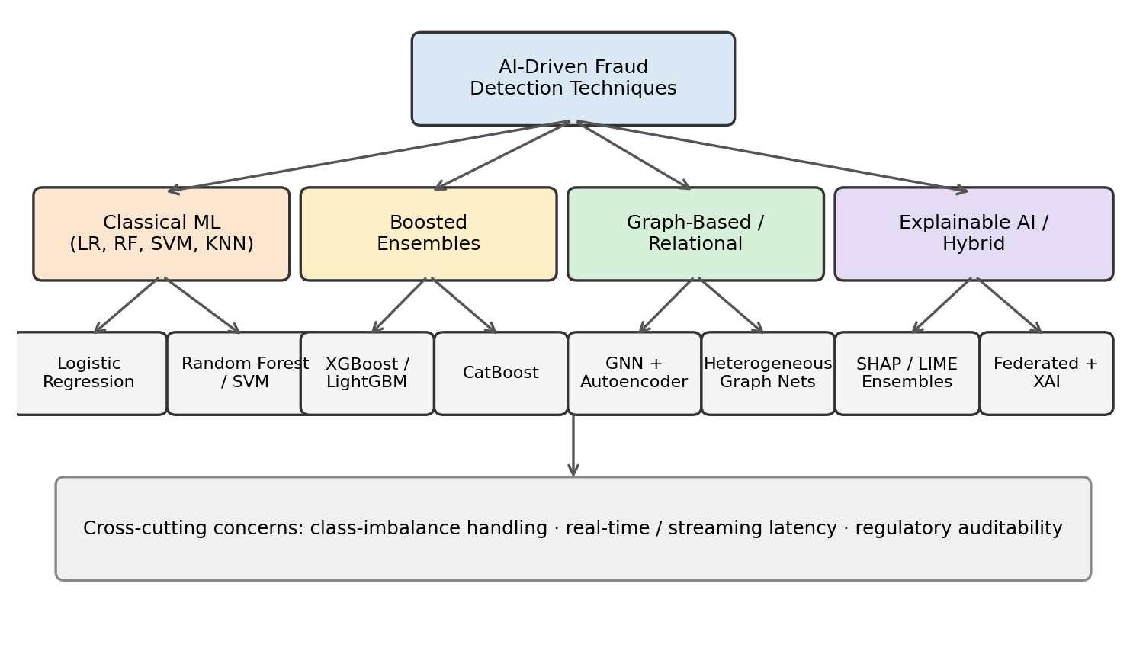
Fig. 1. Taxonomy of the AI-driven fraud detection technique families covered in this survey.
A. Classical Machine Learning Approaches
The earliest and still most widely deployed fraud-detection models are classical supervised classifiers. Comparative studies have evaluated logistic regression, decision trees, random forest, k-nearest neighbours (KNN), support vector machines, and Naive Bayes against public card-transaction datasets, generally finding that ensemble tree methods such as random forest outperform single-model baselines on precision and recall [3], [4], [6], [8]–[10]. A systematic review of these techniques found that dimensionality reduction via Principal Component Analysis is commonly used both to speed up training and to anonymize the underlying cardholder features before public release [3]. This anonymization step matters for reproducibility: it lets researchers publish and compare results without exposing real cardholder data, but it also means the feature semantics fraudsters actually exploit are hidden from anyone re-training the model. Broader survey-style papers position these classical methods as a necessary baseline against which newer deep and graph-based methods must be measured [2], [7], since a sophisticated model that cannot beat a well-tuned random forest on the same data is difficult to justify in production.
B. Deep Learning and Ensemble Methods
Beyond classical classifiers, the literature reports gains from gradient-boosted ensembles — XGBoost, LightGBM, and CatBoost — and from deep sequence models such as LSTM-based fraud classifiers and CNN-based detectors that treat a transaction's feature vector as a fixed-size input analogous to an image [1]. A recent comparative study benchmarking CatBoost, XGBoost, and LightGBM against one another found that the choice of boosting framework mattered less than the feature-engineering and resampling pipeline built around it [1], a finding that echoes a broader pattern in applied ML where data preparation, rather than model architecture, tends to be the larger lever on final performance. Zhao et al. proposed a modified LightGBM formulation specifically tuned for the extreme imbalance ratios seen in production fraud datasets, reporting improved recall on the minority (fraud) class without a large precision penalty [20].
C. Graph-Based and Relational Approaches
A transaction is rarely an isolated event — fraud rings typically reuse devices, IP addresses, shipping addresses, or mule accounts across many transactions, a relational signal that a row-wise classifier cannot see. This has motivated graph neural network (GNN) approaches that model accounts, devices, and merchants as nodes and transactions as edges. Alarfaj and Shahzadi combined a GNN with a Lambda-architecture streaming pipeline for real-time scoring, and an autoencoder for reconstruction-error-based anomaly scoring, validating the approach on case studies from two banks [11]. A broader review of graph-learning approaches to financial fraud catalogues techniques including heterogeneous graph attention networks and dynamic graph neural networks aimed at anti-money-laundering and cash-out-fraud detection, and highlights that most published GNN fraud detectors are evaluated on synthetic or single-institution graphs rather than realistic, multi-institution transaction networks [12]. This is a meaningful limitation, since the coordinated, multi-account fraud rings that GNNs are best suited to catch are precisely the pattern that spans institutional boundaries in practice.
D. Explainable AI and Regulatory Compliance
Because regulators require an auditable rationale for any transaction that is blocked or flagged, a substantial and recent strand of the literature couples high-accuracy models with post-hoc explainability. Almalki and Masud combined a stacking ensemble of XGBoost, LightGBM, and CatBoost with LIME, Partial Dependence Plots, and Permutation Feature Importance, reporting 99% accuracy and a 0.99 AUC-ROC on the IEEE-CIS fraud dataset while retaining per-prediction explanations [13]. Shah proposed a scalable explainable pipeline built around SHAP-style attribution for transaction-level decisions [14], and a further study frames XAI specifically as a trust-and-transparency layer for financial decision-making rather than purely a diagnostic tool [15]. Damanik and Liu went further, combining federated learning — so that no single bank has to centralize raw customer data — with an XAI layer and a hybrid resampling scheme, reporting an F1-score of 0.92 and an AUC-ROC of 1.00 on their evaluation set [16]. A related line of work frames the interpretability requirement explicitly against named regulatory instruments, arguing that a 98%-accurate model that cannot explain a specific flagged transaction is, from a compliance standpoint, not deployable [23].
E. Handling Class Imbalance
Because fraudulent transactions are a small fraction of the total, nearly every surveyed study reports some form of imbalance handling — SMOTE-family oversampling, undersampling of the majority class, cost-sensitive loss weighting, or hybrid resampling such as the K-means–SMOTE–ENN scheme used by Damanik and Liu [16]. Baisholan et al. proposed FraudX AI, an interpretable framework explicitly designed to remain accurate under severe imbalance without over-relying on synthetic minority oversampling, which can introduce unrealistic synthetic fraud patterns into the training set [1]. Zhao et al.'s LightGBM variant similarly targets this problem at the algorithmic level rather than the data level [20]. Taken together, these approaches suggest a rough consensus in the field: imbalance is best handled through a combination of moderate resampling and a loss function that already penalizes false negatives on the minority class more heavily, rather than through resampling alone.
F. Real-Time and Streaming Constraints
A separate but related concern is that a fraud decision that arrives after a payment has already settled is of limited value. Streaming architectures that combine a fast deterministic rules layer, a calibrated ML scoring layer, and a slower graph-based network-analysis layer for organized fraud rings have been proposed to reconcile accuracy with sub-second latency budgets. One recent streaming pipeline explicitly models stochastic delays in obtaining verified fraud labels — a practical constraint largely absent from static benchmark datasets — and couples it with a dynamic decision-threshold manager to balance precision and recall as conditions drift [21]. A 2026 proposal targets the harder "zero-day" case, where a fraud pattern has no historical precedent at all, using a variational autoencoder to model the manifold of legitimate transactions and flag reconstruction-error outliers within a sub-50-millisecond budget [22]. A broader review of deep learning in financial fraud detection frames real-time capability, auditability, and cross-sector transferability as the three axes along which future fraud-detection infrastructure should be judged [17].
G. Synthesis of the Taxonomy
Fig. 1 summarizes the six threads reviewed above as a single taxonomy. Reading the figure left to right roughly tracks the historical order in which these techniques entered the fraud-detection literature: classical models first, then boosted ensembles as gradient-boosting libraries matured, then graph-based methods once relational fraud signals were recognized as under-exploited, and finally explainable-AI wrappers once regulators began asking hard questions about the boosted and graph-based models that had, by then, already been deployed. The bottom banner in the figure — class-imbalance handling, real-time latency, and regulatory auditability — is deliberately drawn as cutting across every branch, because, as Sections II-E, II-F, and II-D respectively make clear, none of the four technique families is exempt from these three constraints; they simply satisfy them to different degrees, which is exactly what Table I in Section IV is designed to make comparable.
III. RESEARCH METHODOLOGY
This paper follows a systematic literature survey methodology rather than an original implementation, consistent with a comparative-study and literature-review problem selection. Candidate papers were identified through structured keyword search — combinations of "fraud detection", "financial transactions", "machine learning", "deep learning", "graph neural network", and "explainable AI" — across IEEE Xplore, Elsevier ScienceDirect, ACM Digital Library, Springer Link, and the arXiv preprint archive for the most recent 2025–2026 work not yet indexed elsewhere. Search results were screened first by title and abstract, and then, for anything not obviously out of scope, by a full read of the methodology and results sections.
Inclusion criteria required that a candidate paper (i) address fraud, anomaly, or intrusion detection specifically within a financial-transaction context; (ii) describe a concrete ML, DL, graph-based, or XAI technique; and (iii) report at least one empirical evaluation metric (accuracy, precision, recall, F1-score, or AUC-ROC) or a clearly stated architectural contribution when the paper was itself a review. Papers addressing fraud in non-financial domains (e.g., insurance claims fraud without a transaction-level model, or academic/exam fraud) were excluded, as were purely conceptual opinion pieces with no described technique. Applying these criteria to an initial pool of over forty candidates yielded twenty-three papers, spanning publication years 2019 to 2026, that form the basis of Section II and Table I.
Each of the twenty-three shortlisted studies was then scored along five comparison dimensions, used consistently in Section IV: (1) Detection Technique — the underlying ML/DL/graph/XAI family used; (2) Dataset — the transaction data source used for evaluation, distinguishing public benchmark datasets (e.g., the 2013 European cardholder dataset, IEEE-CIS) from proprietary bank data; (3) Class-Imbalance Handling — whether and how the study addressed the skew between fraud and non-fraud classes; (4) Interpretability — whether the study reports a post-hoc or intrinsically interpretable explanation for individual predictions; and (5) Real-Time Feasibility — whether the study reports or discusses inference latency suitable for transaction-time scoring rather than offline batch analysis. Two of the authors independently scored each study against these five dimensions and reconciled disagreements by re-reading the relevant section of the source paper, which is a lightweight version of the dual-reviewer protocol common in systematic reviews.
Table III lists the handful of datasets that the surveyed literature actually evaluates against. The heavy repeated reliance on just two public datasets, visible in the "Used By" column, is itself one of the findings of this survey and is discussed further in Section IV-D.

Dataset | Records | Fraud Rate | Used By
2013 European Cardholder | ~285,000 | ~0.17% | [3], [6], [9], [11], [20]
IEEE-CIS Fraud Dataset | ~590,000 | ~3.5% | [13], [16]
Proprietary bank / synthetic graphs | Varies | Not disclosed | [11], [12], [21], [22]
Table III. Public benchmark datasets used across the surveyed literature.
IV. ANALYSIS AND DISCUSSION
Table I summarizes the surveyed literature against the five-dimension comparison framework described in Section III. The table groups studies by technique family rather than by individual citation, since several papers within a family report broadly similar trade-offs.

Technique Family | Representative Studies | Interpretability | Real-Time Feasibility | Key Limitation
Classical ML (LR, RF, SVM, KNN) | [2]–[4], [6], [8]–[10] | High (intrinsic) | High | Ceiling on accuracy for subtle, non-linear fraud patterns
Boosted ensembles (XGBoost, LightGBM, CatBoost) | [1], [20] | Low–Medium | High | Needs post-hoc XAI layer for compliance
Graph Neural Networks | [11], [12] | Low | Medium | Scales poorly to million-node transaction graphs
Explainable AI / hybrid ensembles | [13]–[16], [23] | High (post-hoc) | Medium | Explanation methods (SHAP/LIME) add inference overhead
Streaming / real-time architectures | [17], [21], [22] | Varies | Very High | Limited evaluation on realistic label-delay conditions
Table I. Comparison of AI-driven fraud detection technique families.
A. Accuracy Trends
Reported accuracy and AUC-ROC figures across the surveyed studies are consistently high — several boosted-ensemble and GNN-based papers report accuracy or AUC above 0.99 [11], [13]. However, the overwhelming majority of these results come from a small number of public benchmark datasets, most prominently the 2013 European cardholder card-transaction dataset and the IEEE-CIS fraud dataset. Both datasets are now years old and PCA-anonymized, meaning the raw feature semantics fraudsters actually exploit today are not directly visible in the data models are trained and benchmarked on. This raises a real concern about how well reported accuracy figures generalize to present-day fraud patterns on live, unanonymized transaction streams — a near-perfect AUC-ROC on a decade-old, anonymized dataset says comparatively little about how a model would fare against a fraud ring operating this quarter.
B. The Interpretability–Latency Trade-off
A clear tension recurs across the surveyed literature: the models with the strongest raw predictive performance — deep neural networks, GNNs, boosted ensembles — are the least interpretable by default, while intrinsically interpretable models such as logistic regression and single decision trees tend to underperform on subtle fraud patterns. Fig. 2 plots the technique families surveyed in Section II along these two axes; the families cluster fairly cleanly into a fast-but-opaque group (boosted ensembles), a slow-but-opaque group (GNNs), and a group that pays a latency premium specifically to buy back interpretability (SHAP/LIME ensembles, federated XAI).
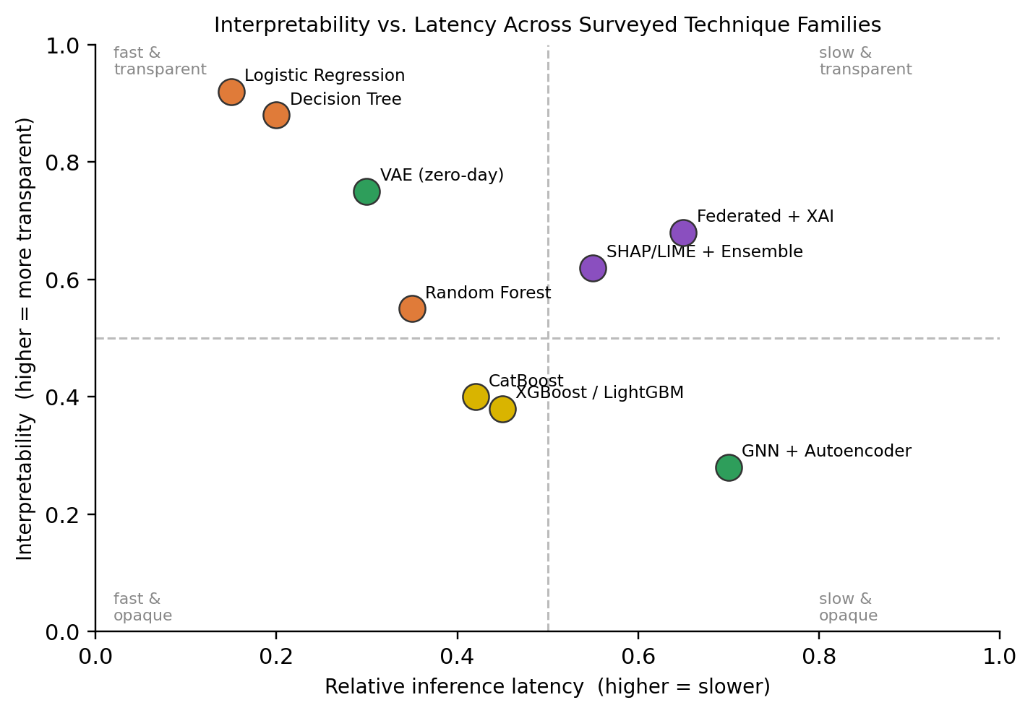
Fig. 2. Interpretability vs. latency across the surveyed technique families.
Post-hoc explainability techniques such as SHAP and LIME bridge this gap but at a measurable computational cost; one production-oriented study reports that SHAP-based explanation adds roughly 30 milliseconds per prediction at a modest background-sample size, which is a meaningful fraction of the sub-100-millisecond latency budgets that real-time payment rails such as FedNow or RTP-style instant transfer systems demand [22]. This suggests that architecture choices which fuse prediction and explanation into a single lightweight pass — rather than bolting a separate explainer onto an opaque model — are likely to matter more in production than marginal gains in raw accuracy.
C. Regulatory Pressure as a Design Driver
Several of the most recent papers surveyed treat regulatory compliance not as an afterthought but as a first-class design constraint, explicitly citing supervisory instruments such as the OCC's model-risk guidance and the Federal Reserve's SR 11-7 as reasons a model must be auditable before it can be deployed for high-risk financial decisions [23]. This is a meaningful shift from earlier literature, which optimized almost exclusively for classification accuracy on a static benchmark. It also explains the recent popularity of federated learning combined with XAI: federated approaches let multiple institutions collaboratively train a shared detector without centralizing sensitive customer data, addressing both a privacy constraint and, indirectly, a compliance constraint [16]. In effect, the field is converging on the view that a fraud model's regulatory defensibility is now a first-order design requirement, on par with its raw detection accuracy, rather than a secondary concern to be addressed after the fact.
D. Open Gaps
Three gaps recur across the surveyed literature. First, there is no standardized, realistic, present-day benchmark dataset for financial fraud research; nearly all reported results trace back to one of two aging, heavily anonymized public datasets, which limits comparability and may overstate generalizable accuracy. Second, adversarial and zero-day robustness is rarely evaluated rigorously — most studies assume the fraud patterns seen at test time resemble those seen at training time, an assumption fraud rings actively violate, and only a small number of very recent papers explicitly target the zero-day case [22]. Third, cross-institution collaboration remains nascent: while federated learning is proposed as a partial solution, published evaluations still tend to simulate federation across partitions of a single dataset rather than genuinely heterogeneous data from multiple real institutions [16].
Taken together, these gaps point toward a promising direction for future systems: an architecture that combines graph-based relational modeling of accounts, devices, and merchants (to catch coordinated fraud rings that transaction-level classifiers miss) with a lightweight, natively interpretable scoring head (to avoid the latency penalty of bolted-on post-hoc explanation) and a federated training protocol (to allow multiple institutions to jointly benefit from each other's fraud signal without violating data-sharing regulations).
E. Practical Implications for Financial Institutions
For a practitioner deciding what to actually build rather than what to publish, the survey suggests a fairly pragmatic reading. A classical or boosted-ensemble model is still a reasonable default for a first production deployment, given its low latency and mature tooling, provided it is paired with a post-hoc explanation layer to satisfy auditability requirements from day one rather than retrofitted later. Graph-based and federated approaches are best reserved for the smaller volume of transactions that a first-pass model already flags as suspicious, both because they are more expensive to run and because their main advantage — seeing relationships across accounts and, ideally, across institutions — only pays off once there is a plausible ring to detect in the first place. This layered, escalate-only-when-necessary pattern recurs often enough in the surveyed streaming literature [17], [21] that it is treated here as a design principle rather than an isolated implementation choice, and it directly motivates the architecture proposed in Section V.
V. TOWARDS A HYBRID DETECTION ARCHITECTURE
The gaps identified in Section IV motivate a concrete conceptual architecture, sketched here as a direction for follow-on implementation work rather than as a system we built and evaluated ourselves. The design borrows a three-layer structure that recurs implicitly across the surveyed literature — a fast deterministic layer, a learned scoring layer, and a relational layer — and adds a fourth, explanation layer that is designed in from the start rather than bolted on afterward.
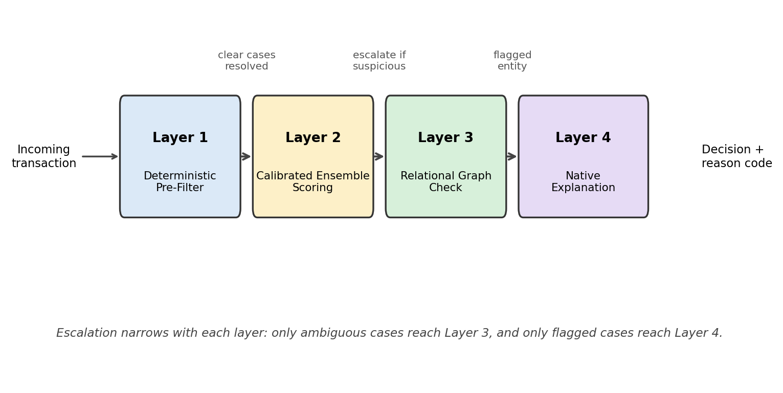
Fig. 3. Proposed four-layer hybrid fraud-detection pipeline, with escalation narrowing at each stage.
A. Layer 1 — Deterministic Pre-Filter
A lightweight rules layer (velocity checks, geo-mismatch checks, known-bad-payee lists) runs first, at negligible computational cost, to dispose of the clearest cases — both obvious fraud and clearly legitimate low-risk transactions — before any model inference is invoked. This mirrors the velocity-and-rules layer described in industry deployments of real-time fraud pipelines and keeps the average-case latency low, since only the harder, ambiguous transactions need to reach the more expensive layers below [21].
B. Layer 2 — Calibrated Ensemble Scoring
Transactions that pass the pre-filter are scored by a boosted-ensemble model (in the spirit of the LightGBM and XGBoost approaches surveyed in Section II-B), chosen over a full deep neural network for its favorable balance of accuracy and inference cost on tabular transaction features. The model is trained with a cost-sensitive loss and an imbalance-aware resampling strategy such as K-means–SMOTE–ENN, following the approach validated by Damanik and Liu, so that the rare fraud class is not drowned out during training [16].
C. Layer 3 — Relational Graph Check
Only transactions flagged as suspicious by Layer 2 are escalated to a graph-based relational check, which looks at whether the account, device fingerprint, or payee is connected to other recently flagged entities within a rolling transaction graph. Restricting graph inference to the minority of escalated transactions, rather than running it on every transaction, directly addresses the scalability limitation of GNN-based approaches noted in Section IV-D, since the graph traversal only needs to run at a small fraction of full transaction volume.
D. Layer 4 — Native Explanation
Rather than attaching a separate SHAP or LIME explainer after the fact, the scoring model in Layer 2 is trained jointly with an interpretable attention or feature-attribution head, so that a human-readable reason code (e.g., "unusual merchant category for this account" or "device seen on three previously flagged accounts") is produced as a direct output of inference rather than as a second, costlier pass. This is intended to preserve the auditability that regulatory guidance such as SR 11-7 requires [23], without reintroducing the roughly 30-millisecond post-hoc explanation overhead reported in production deployments of separately bolted-on explainers [22].
Table II summarizes how each layer of this conceptual architecture maps back to the corresponding gap identified in the literature survey.

Layer | Gap Addressed
1. Deterministic pre-filter | Keeps average latency low for real-time feasibility
2. Calibrated ensemble | Accuracy under extreme class imbalance
3. Relational graph check | Scalable detection of coordinated fraud rings
4. Native explanation | Regulatory auditability without post-hoc latency
Table II. Mapping of proposed architecture layers to literature gaps.
VI. THREATS TO VALIDITY
As with any literature survey, the conclusions drawn here are shaped by the choices made during paper selection, and it is worth being explicit about where those choices could bias the picture presented in Sections II and IV.
A. Publication and Venue Bias
The search process favored IEEE Xplore, ACM, Elsevier, and Springer venues plus arXiv preprints, which skews the sample toward work that is either already peer-reviewed at a computer-science venue or actively being positioned for such a venue. Practitioner reports, internal bank white papers, and vendor case studies — which might describe production systems quite different from what gets published academically — are largely absent from the twenty-three studies reviewed, and the real-world performance figures reported by academic papers may not transfer directly to a live production environment with different fraud patterns, latency constraints, and data quality.
B. Benchmark Dataset Concentration
As Table III makes explicit, a large share of the reviewed empirical results are reported on just two public datasets. This is not a flaw specific to any individual study — it reflects a genuine scarcity of realistic, labeled, and legally shareable fraud data — but it does mean that the strong accuracy figures summarized in Section IV-A should be read as a comment on model performance against those two specific, aging datasets rather than as a general claim about performance against arbitrary present-day fraud.
C. Reviewer and Selection Subjectivity
The five-dimension scoring described in Section III involved a degree of judgment, particularly for the Interpretability and Real-Time Feasibility columns, where source papers do not always report a clean, comparable number. Where a paper's language was ambiguous, the more conservative rating was chosen, which likely means the framework in Table I understates rather than overstates how favorable the surveyed techniques are along these two dimensions.
D. Temporal Scope
Finally, the twenty-three studies span 2019 to 2026, a window during which both the fraud landscape and the underlying ML tooling changed substantially — GNN-based fraud detection, for instance, barely appears in the earlier end of that range. Grouping a 2019 classical-ML paper and a 2026 zero-day detection paper into the same comparison framework in Table I is a simplification, and a reader should weigh the more recent studies more heavily when judging what the current state of the art actually looks like, rather than treating every row in Table I as equally current.
VII. CONCLUSION
This paper surveyed twenty-three recent studies on AI-driven fraud detection in financial transactions, comparing classical machine learning, deep and graph-based learning, and explainable-AI approaches along five dimensions: detection technique, dataset, class-imbalance handling, interpretability, and real-time feasibility. The literature shows clear and consistent gains in raw detection accuracy from moving beyond static rule-based systems to ML and DL models, and a more recent, welcome shift toward treating explainability and regulatory auditability as first-class design requirements rather than an afterthought.
At the same time, the survey surfaces three open problems that the field has not yet resolved: the reliance on aging, heavily anonymized benchmark datasets; weak evaluation of zero-day and adversarial robustness; and limited genuine cross-institution collaboration. Building on these gaps, Section V sketched a four-layer conceptual architecture — deterministic pre-filter, calibrated ensemble scoring, relational graph escalation, and natively interpretable explanation — as a concrete direction for follow-on implementation work. Section VI additionally reflected on the limitations of the survey methodology itself, particularly its reliance on academic venues and on a small number of aging benchmark datasets.
Future work should target building and evaluating the proposed architecture, together with a privacy-preserving federated training protocol, against a more realistic and continuously updated transaction dataset than the field currently relies on. A natural next step beyond this survey would be an empirical replication of at least one representative technique from each family in Table I under a common, present-day evaluation harness, which would let the accuracy, latency, and interpretability figures in this paper be compared on equal footing rather than taken from disparate original studies.
REFERENCES
[1] K. Ghosh Dastidar, O. Caelen, and M. Granitzer, "Machine learning methods for credit card fraud detection: A survey," IEEE Access, 2024.
[2] "A Systematic Literature Survey on Credit Card Fraud Detection using Machine Learning Techniques," in Proc. IEEE Conf., IEEE Xplore, 2025.
[3] "Machine Learning based Credit Card Fraud Detection," in Proc. IEEE Conf., IEEE Xplore, 2023.
[4] "A Survey on Credit Card Fraud Detection Using Machine Learning," in Proc. IEEE Conf., IEEE Xplore, 2019.
[5] "Credit Card Fraud Detection Using State-of-the-Art Machine Learning and Deep Learning Algorithms," IEEE Access, 2022.
[6] "Credit Card Fraud Detection Using Machine Learning," in Proc. IEEE Conf., IEEE Xplore, 2024.
[7] "Machine Learning Methods for Credit Card Fraud Detection: A Survey," IEEE Journals & Magazine, 2024.
[8] "Machine Learning For Detecting Credit Card Fraud," in Proc. IEEE Conf., IEEE Xplore, 2023.
[9] "Machine Learning based Credit Card Fraud Detection - A Review," in Proc. IEEE Conf., IEEE Xplore, 2022.
[10] "Credit Card Fraud Identification Using Machine Learning Approaches," in Proc. IEEE Conf., IEEE Xplore, 2019.
[11] F. K. Alarfaj and S. Shahzadi, "Enhancing fraud detection in banking with deep learning: Graph neural networks and autoencoders for real-time credit card fraud prevention," IEEE Access, vol. 13, pp. 20633–20646, 2024.
[12] D. Cheng et al., "Graph Neural Networks for Financial Fraud Detection: A Review," arXiv:2411.05815, 2024.
[13] F. Almalki and M. Masud, "Financial Fraud Detection Using Explainable AI and Stacking Ensemble Methods," arXiv:2505.10050, 2025.
[14] S. B. Shah, "Advancing Financial Security with Scalable AI: Explainable Machine Learning Models for Transaction Fraud Detection," in Proc. 4th Int. Conf. Distributed Computing and Electrical Circuits and Electronics (ICDCECE), 2025, doi: 10.1109/ICDCECE65353.2025.11034838.
[15] "Explainable AI for Fraud Detection: Enhancing Transparency and Trust in Financial Decision-Making," in Proc. IEEE Conf., IEEE Xplore, 2024.
[16] A. Damanik and Y. Liu, "Secure and Transparent Banking: Explainable AI-Driven Federated Learning Model for Financial Fraud Detection," Int. J. Financial Studies, vol. 13, no. 4, p. 179, 2025.
[17] "AI-Enhanced Data Mining for Fraud Detection in Financial Transactions," in Proc. IEEE Conf., IEEE Xplore, 2025.
[18] "Fraud Detection in Financial Transactions Using AI," in Proc. IEEE Conf., IEEE Xplore, 2025.
[19] A. F. Sariat, I. J. Siddique, M. Hossain, M. M. Islam, and T. Rahman, "AI Driven Fraud Detection in Financial Ecosystems: A Hybrid Machine Learning Framework," in Proc. Int. Conf. Electrical, Computer and Communication Engineering (ECCE), 2025, doi: 10.1109/ECCE64574.2025.11013808.
[20] X. Zhao, Y. Liu, and Q. Zhao, "Improved LightGBM for Extremely Imbalanced Data and Application to Credit Card Fraud Detection," IEEE Access, 2024.
[21] "Adaptive Real-Time Financial Fraud Detection with Explainable AI Tools," ACM Digital Threats: Research and Practice, 2026, doi: 10.1145/3794859.
[22] "Review: Deep Learning in Financial Fraud Detection," ScienceDirect, 2025.
[23] N. A. Ismail and E. Karaarslan, "A Dual-Path Generative Framework for Zero-Day Fraud Detection in Banking Systems," arXiv, 2026.

